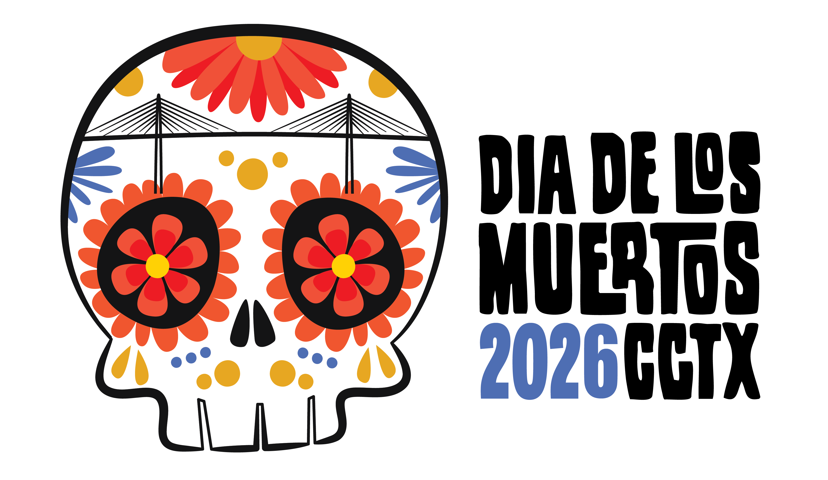
BUENOS VECINOS
SPONSORSHIPS

Special Sponsorship for Neighboring Businesses within the Festival Zone

Dear Neighbor,
As a valued business located within the Corpus Christi Día de los Muertos Festival zone, we invite you to be part of one of our community's most celebrated cultural events by becoming a Buenos Vecinos Sponsor. The event is scheduled for Saturday, Oct. 24, 2026. The event brings thousands of attendees each year.
The sidewalk in front of your business entrance will remain open for pedestrian access throughout the festival. However, please note that if your business has not purchased a Buenos Vecinos Sponsorship, Festival vendors may be placed on the street in front of your building. Becoming a Buenos Vecinos Sponsor reserves additional street space in front of your door.

Additional Sponsorship Benefits - As a Buenos Vecinos Sponsor, you'll also receive:
- Your business logo featured in the Sponsor Slideshow on the Main Stage throughout the event
- Your logo displayed on the festival map on the event website and print materials:
- Your social media stories shared on the festival's social media channels (@diadelosmuertoscc)
To become a Buenos Vecinos Sponsor, complete the form below and return it to K Space Contemporary, or visit: www.diadelosmuertoscc.com/plans-pricing to sign up online. Simply select the appropriate dollar amount. Once your payment is received, a member of our team will contact you with additional details.
Thank you for supporting the Corpus Christi Día de los Muertos Festival. Your participation helps us celebrate our community, culture, and local businesses while creating an unforgettable experience for thousands of visitors. We look forward to partnering with you!

Select Sponsorship Level: Print Deadline - Oct. 1
- $250 – Reserves 10’ of open space on the street in front of your business
- $500 – Reserves 20’ of open space on the street in front of your business
- $1000 – Reserves 30’ of open space on the street in front of your business

Business Name:
Contact Name:
Address (City, State, Zip):
Telephone: Email Address:
- Please Invoice me at the email address above
- Check Enclosed

Email completed form to K Space Contemporary at info@kspacecontemporary.org or deliver to
623 N. Chaparral, CCTX 78401, 361-887-6834, www.kspacecontemporary.org

Event Website: www.diadelosmuertoscc.com

